CSA5103-Cryptography And Network Security
LAB PPROGRAMS
EXP-1
Write a python program for Caesar cipher involves replacing each letter of the alphabet with the letter standing k places further down the alphabet, for k in the range 1 through 25.
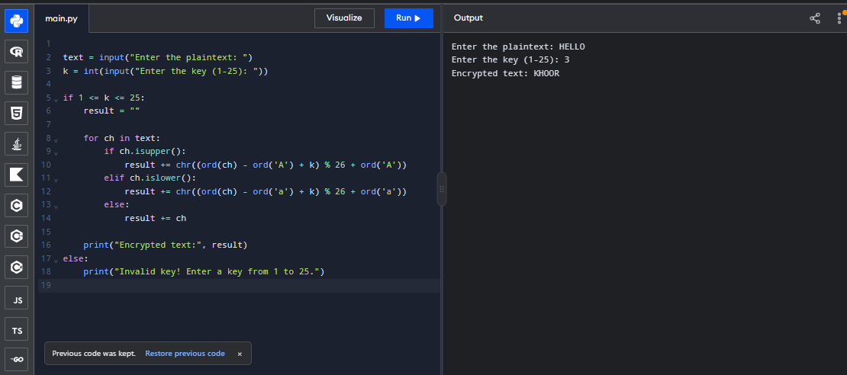
EXP-2
Write a python program for monoalphabetic substitution cipher maps a plaintext alphabet to a ciphertext alphabet, so that each letter of the plaintext alphabet maps to a single unique letter of the ciphertext alphabet.
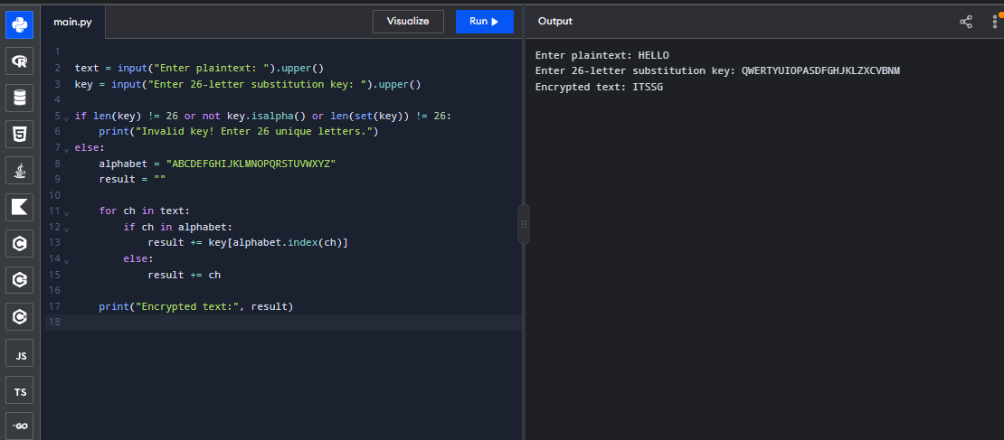

EXP-3
Write a python program for Playfair algorithm is based on the use of a 5 X 5 matrix of letters constructed using a keyword. Plaintext is encrypted two letters at a time using this matrix.
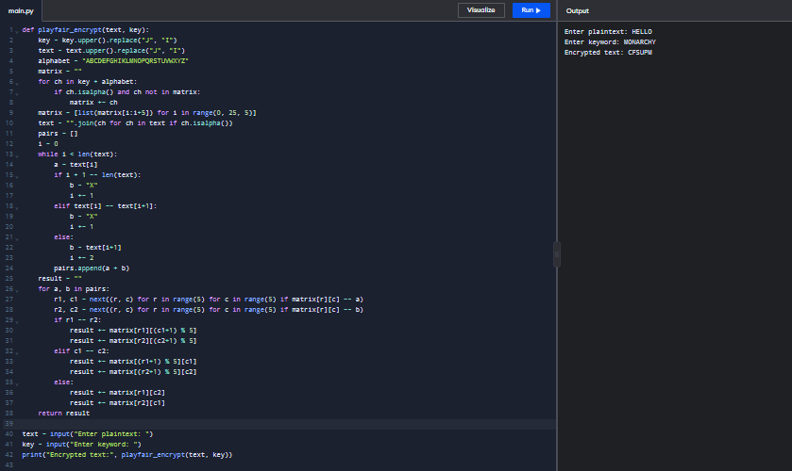
EXP-4
Write a python program for polyalphabetic substitution cipher uses a separate monoalphabetic substitution cipher for each successive letter of plaintext, depending on a key.
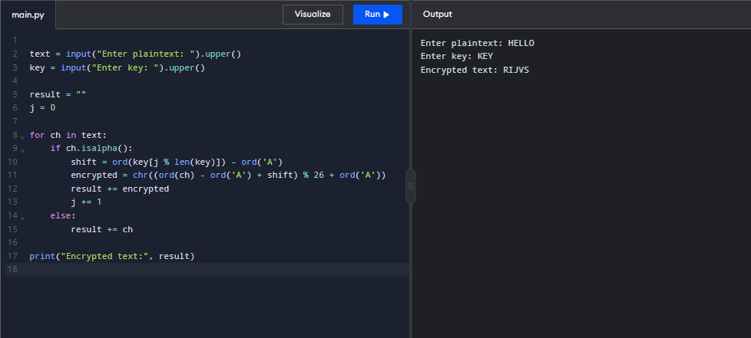

EXP-5
Write a python program for generalization of the Caesar cipher
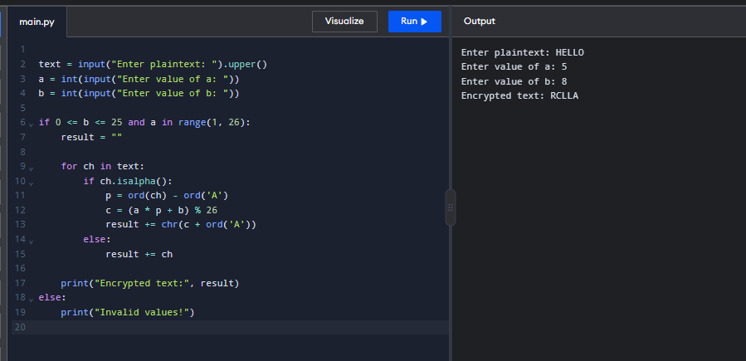
EXP-6
Write a python program for ciphertext has been generated with an affine cipher. The most frequent letter of the ciphertext is “B,” and the second most frequent letter of the ciphertext is “U.”Break this code.
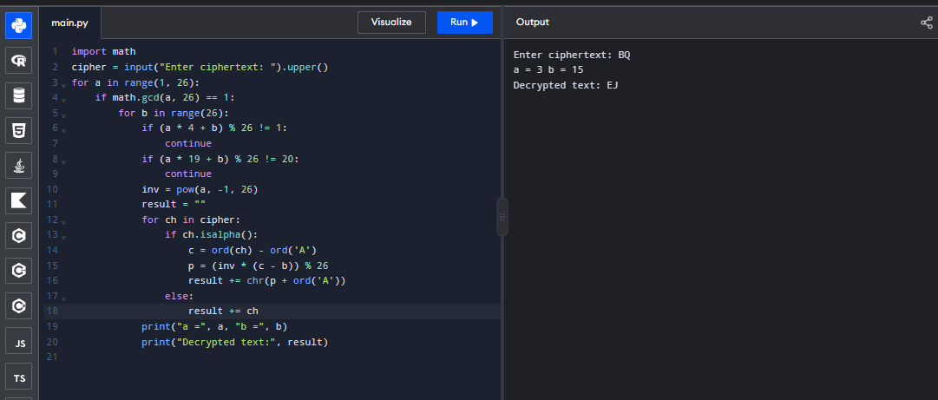
EXP-7
Write a python program for the following ciphertext was generated using a simple substitution algorithm.
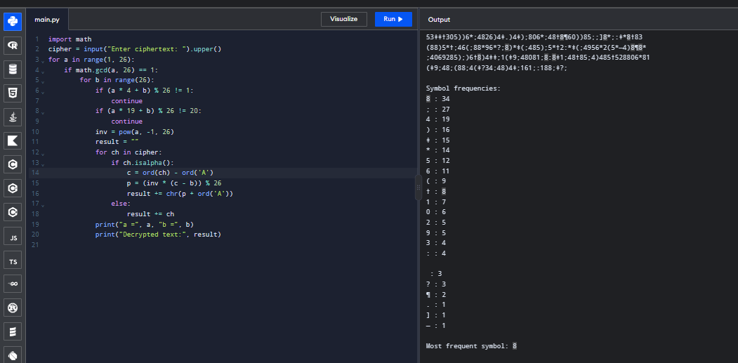
EXP-8
Write a python program for monoalphabetic cipher is that both sender and receiver must commit the permuted cipher sequence to memory.
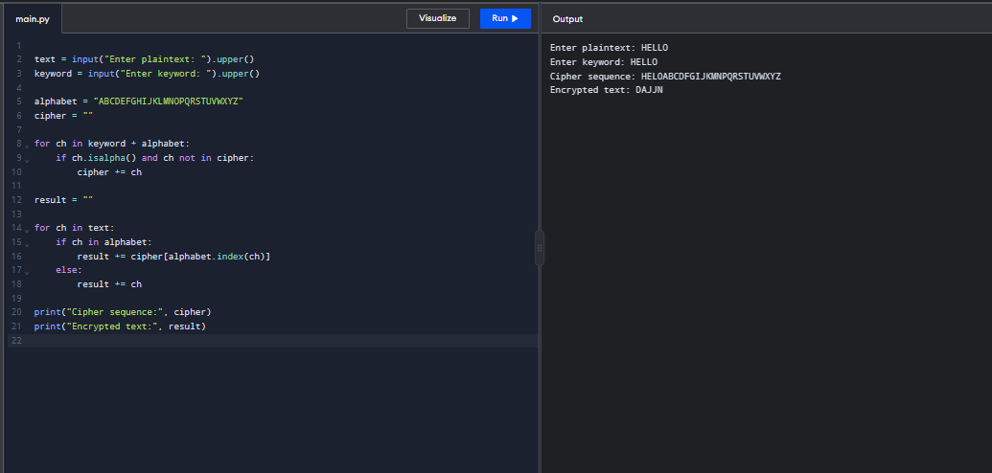
EXP-9
Write a python program for PT-109 American patrol boat, under the command of Lieutenant John F. Kennedy, was sunk by a Japanese destroyer, a message was received at an Australian wireless station in Playfair code:

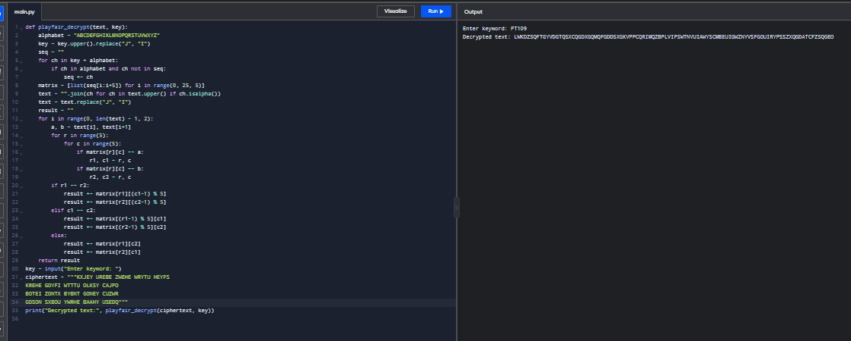
EXP-10
Write a python program for Playfair matrix:
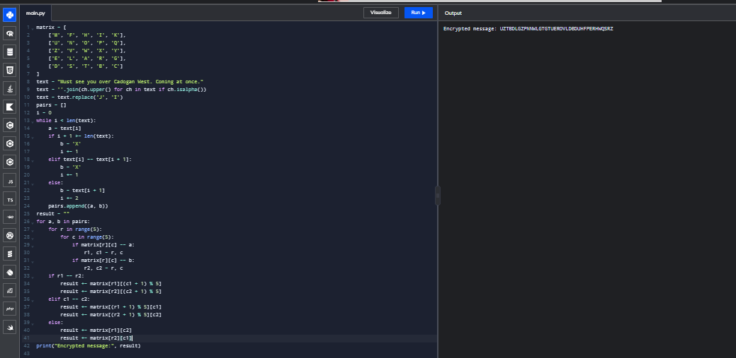
EXP-11
Write a python program for possible keys does the Playfair cipher have? Ignore the fact that some keys might produce identical encryption results. Express your answer as an approximate power of 2.
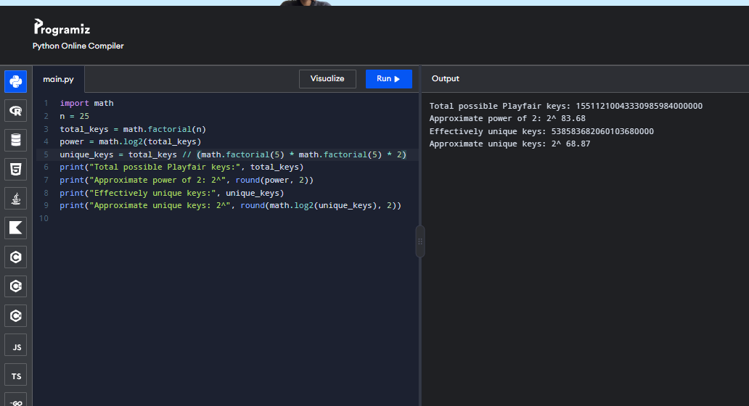
EXP-12
Write a python program to Encrypt the message “meet me at the usual place at ten rather than eightoclock” using the Hill cipher with the key.
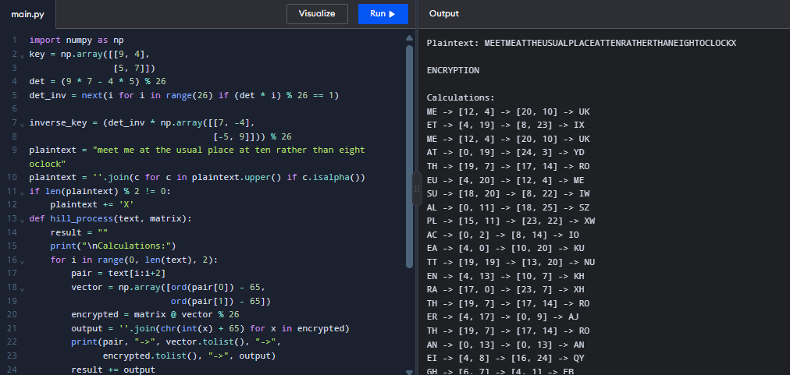
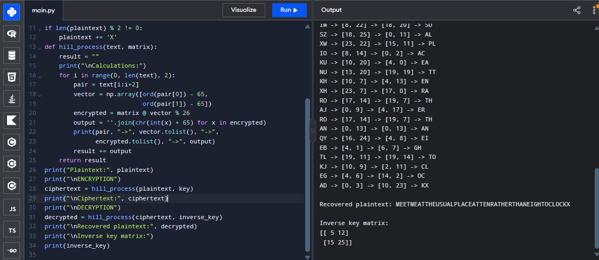
EXP-13
Write a python program for Hill cipher succumbs to a known plaintext attack if sufficient plaintext–ciphertext pairs are provided. It is even easier to solve the Hill cipher if a chosen plaintext attack can be mounted.
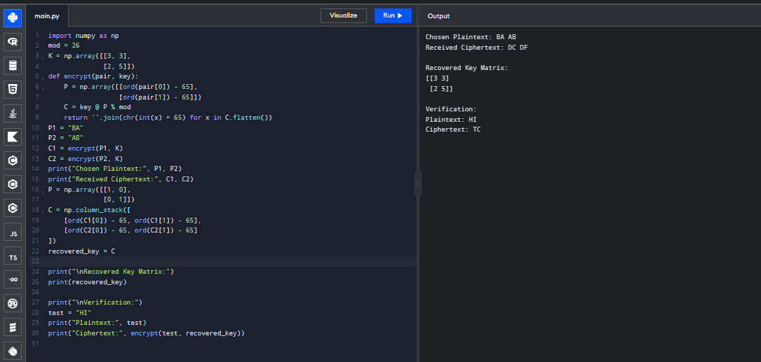

EXP-14
Write a python program for one-time pad version of the Vigenère cipher.
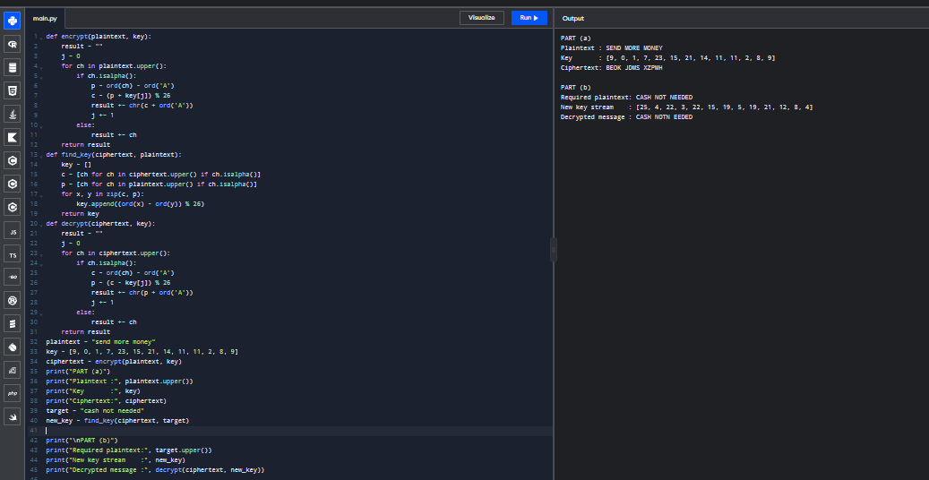
Exp-15
Write a python program that can perform a letter frequency attack on an additive cipher without human intervention.
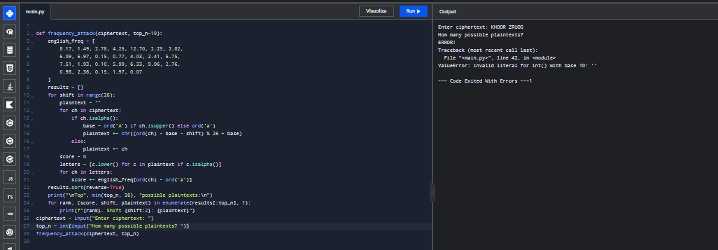
EXP-16
16. Write a C program that can perform a letter frequency attack on any monoalphabetic substitution cipher without human intervention. Your software should produce possible plaintexts in rough order of likelihood. It would be good if your user interface allowed the user to specify “give me the top 10 possible plaintexts.”

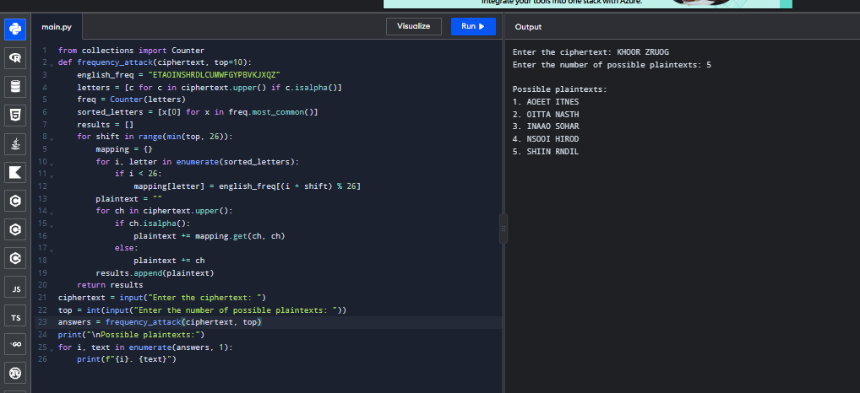
EXP-17
17. Write a python program for DES algorithm for decryption, the 16 keys (K1, K2, c, K16) are used in reverse order. Design a key-generation scheme with the appropriate shift schedule for the decryption process.
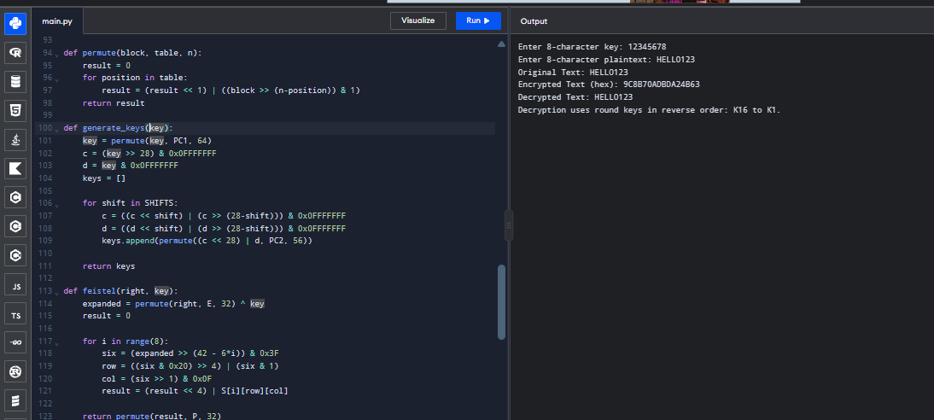
EXP-18
18. Write a python program for DES the first 24 bits of each subkey come from the same subset of 28 bits of the initial key and that the second 24 bits of each subkey come from a disjoint subset of 28 bits of the initial key.
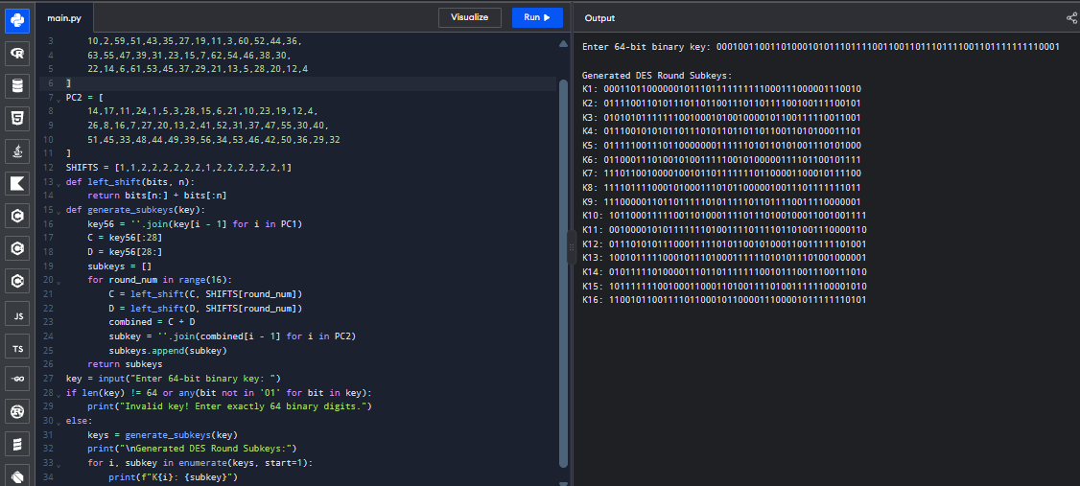
19. Write a python program for encryption in the cipher block chaining (CBC) mode using an algorithm stronger than DES. 3DES is a good candidate. Both of which follow from the definition of CBC. Which of the two would you choose:
a. For security?
b. For performance?
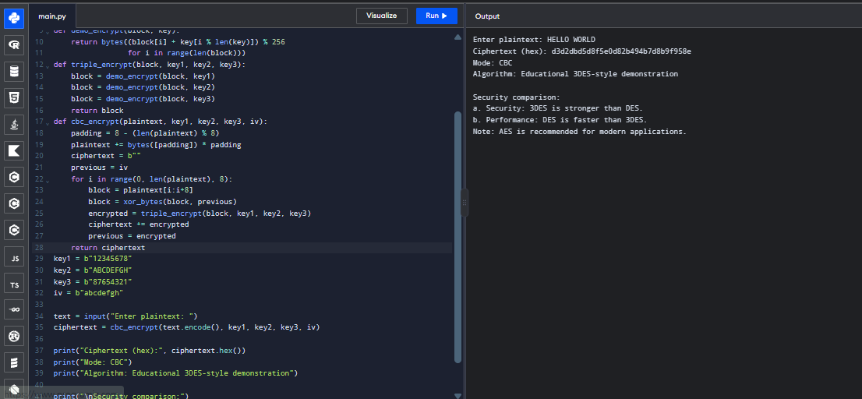
20. Write a python program for ECB mode, if there is an error in a block of the transmitted ciphertext, only the corresponding plaintext block is affected. However, in the CBC mode, this error propagates. For example, an error in the transmitted C1 obviously corrupts P1 and P2.
a. Are any blocks beyond P2 affected?
b. Suppose that there is a bit error in the source version of P1. Through how many
ciphertext blocks is this error propagated? What is the effect at the receiver?
